***MODUAL -4 CSS AND CSS3***

**Q.1) What are the benefits of using CSS?**

**Ans)**

- CSS separates the structure and content (HTML) from the presentation and style.

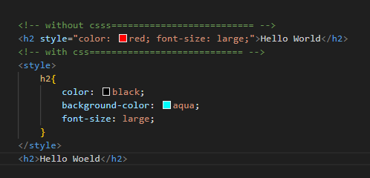

- CSS allows you to define styles centrally and apply them consistently across multiple pages.

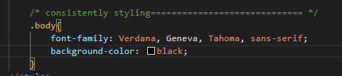

- CSS supports responsive design, enabling web pages to adapt to different screen sizes and devices.

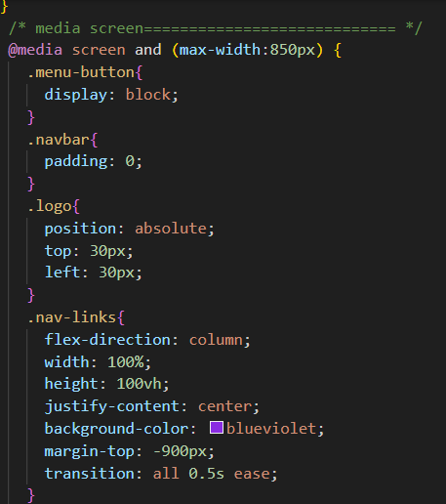

- CSS facilitates the reuse of styles across different elements or pages. By defining classes and IDs, you can apply the same styling to multiple elements without duplicating code.

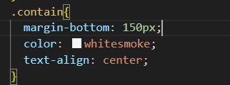

5)Ease of Maintenance: - Centralizing styles in external CSS files makes it easier to update the appearance of a website.

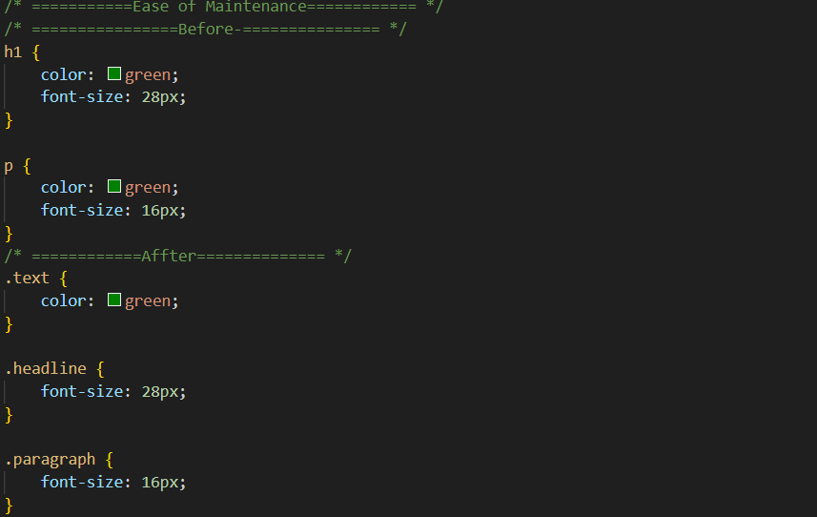

**Q.2) What are the disadvantages of CSS?**

***Ans)***

-The style defined for `p` will apply globally to all `<p>` elements on the page. This can lead to unintentional styling conflicts.

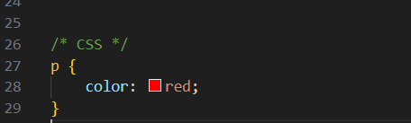

- Achieving complex layouts, especially vertical centering, can be challenging without resorting to hacks or using additional technologies like Flexbox or Grid.

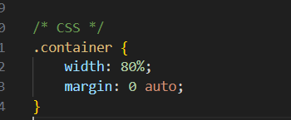

-Beginners might find certain CSS concepts, such as positioning and the box model, challenging to grasp initially.

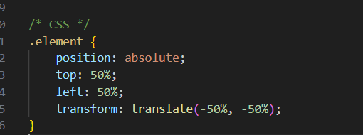

- Overusing animations or applying complex styles to a large number of elements can lead to performance issues, affecting page load times.

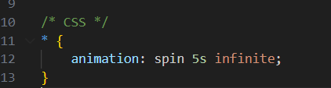

- CSS doesn't have built-in conditional logic, making it challenging to apply styles based on dynamic conditions without using additional tools or preprocessors.

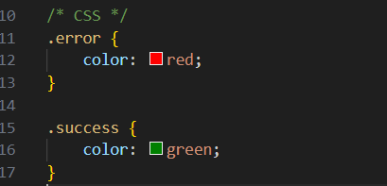

***Q.3) What is the difference between CSS2 and CSS3?***

***Ans)***

**=>CSS** (Cascading Style Sheets) is a stylesheet languag. CSS2 and CSS3 represent different versions of the CSS specification, each introducing new features and improvements.

**=>CSS2:-**

CSS2 was the second version of the CSS specification and was released in 1998. It introduced several important features for web styling, including:-

**=>postion:**

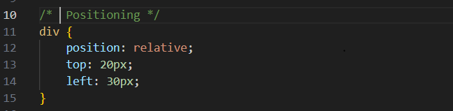

**=>Z-Index:**

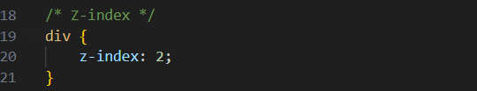

**=>Float:-**

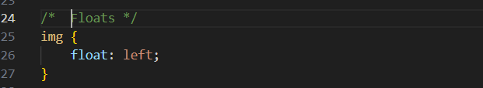

**CSS3:-**

CSS3 is the latest version of the CSS specification, and it introduces even more features and enhancements.

**Border radius=>**

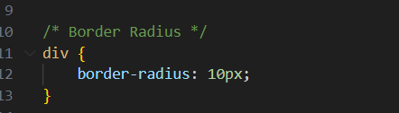

**Box shadow=>**

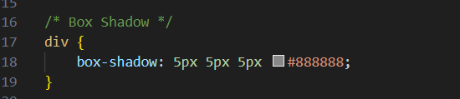

**Transtion=>**

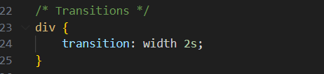

**Flexbox=>**

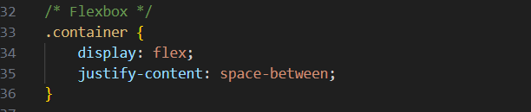

**Grid Layout=>**

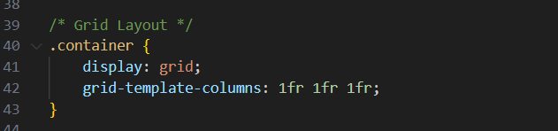

**Media Query**

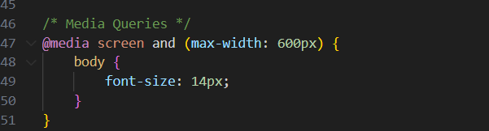

**Q.4) Name a few CSS style components.**

**Ans)**

**=>Color :**

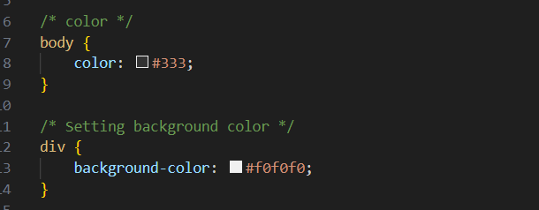

**=>Font :**

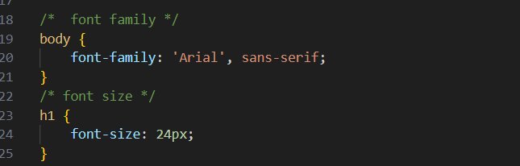

**=>Padding And Margin :**

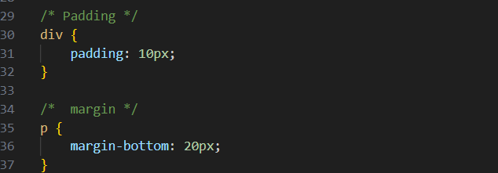

**=>Border :**

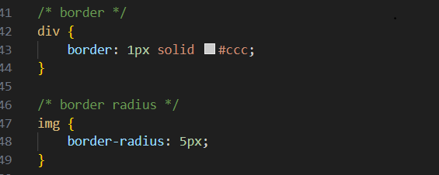

=> **Box Shadow :**

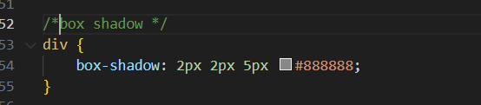

**=>Text Decoration:**

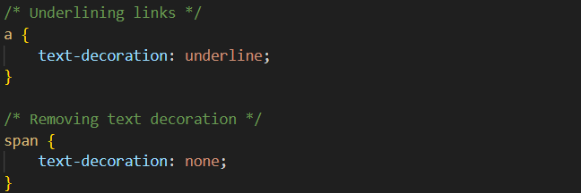

**=>Display:**

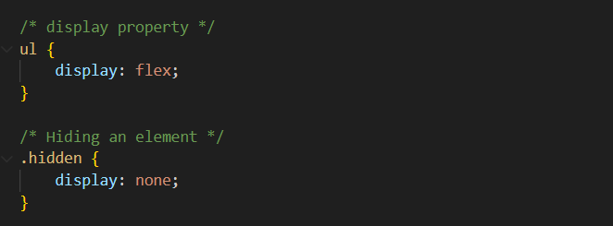

**=>FlexBox:-**

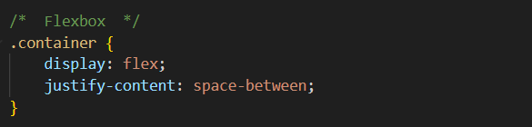

**=>Grid Layout:-**

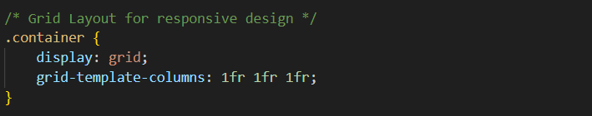

**=>Transition:-**

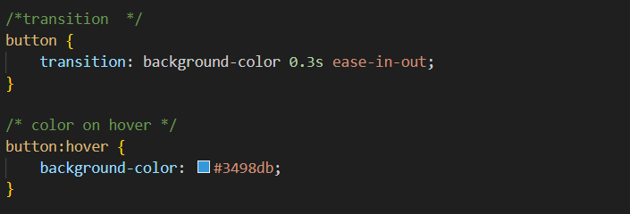

**Q.5) What do you understand by CSS opacity?**

**Ans)**

=>The opacity property takes a value between 0 and 1, where 0 is fully transparent (invisible), 1 is fully opaque (completely visible), and values between 0 and 1 represent varying levels of transparency.

**=>Example:-**

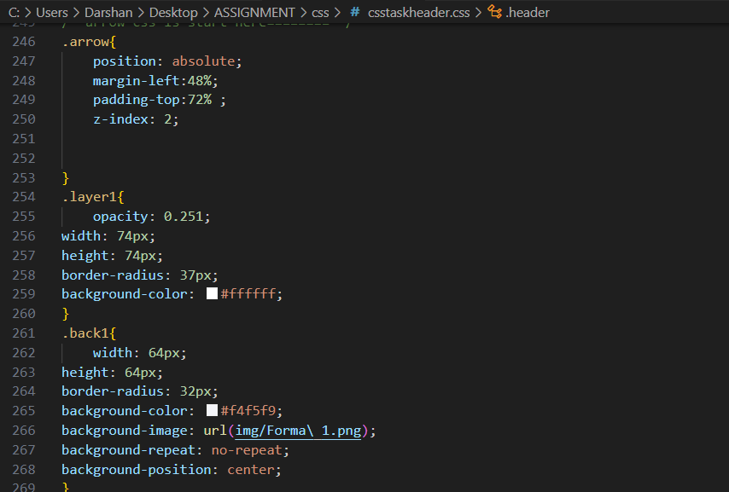

**Q.6) How can the background color of an element be changed?**

**Ans)**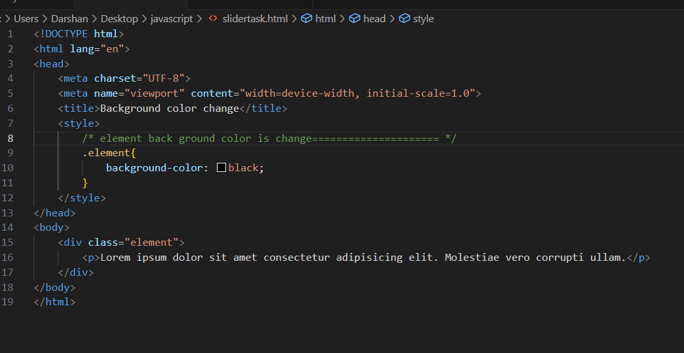

**Q.7) How can image repetition of the backup be controlled?**

**Ans)**

* If you're using to controlling the repetition of a background image you can use the background-repeat property. The background-repeat property has several values, such as repeat, repeat-x, repeat-y, and no-repeat, to control how the background image is repeated.
* **Example:-**

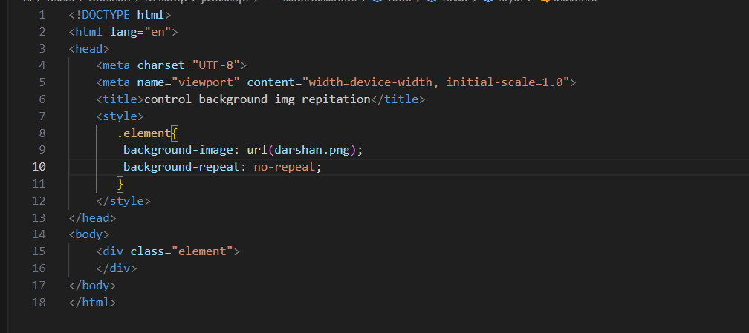

**Q.8) What is the use of the background-position property?**

**Ans)**

=>The background-position property used to specify the starting position of a background image.

=>The values for background-position can be specified in various ways, including keywords, percentages, or length units.

**=>Example:-**

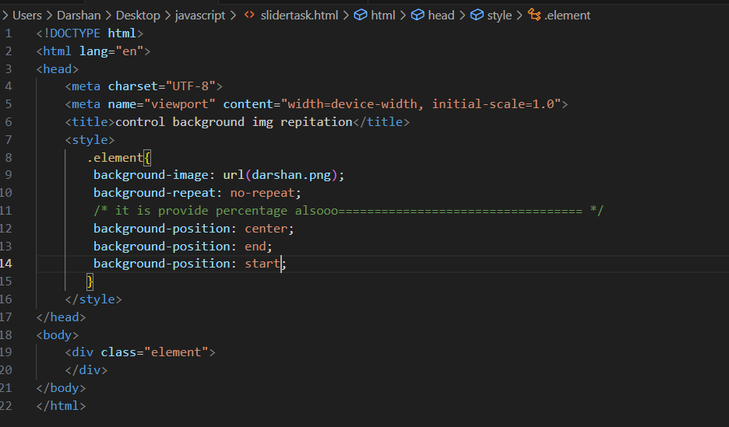

**Q.9) Which property controls the image scroll in the background?**

**Ans)**

=>The property that controls the scrolling behavior of a background image is the background-attachment property.

=>The background-attachment property can take the values scroll, fixed, or local.

**=>Example:-**

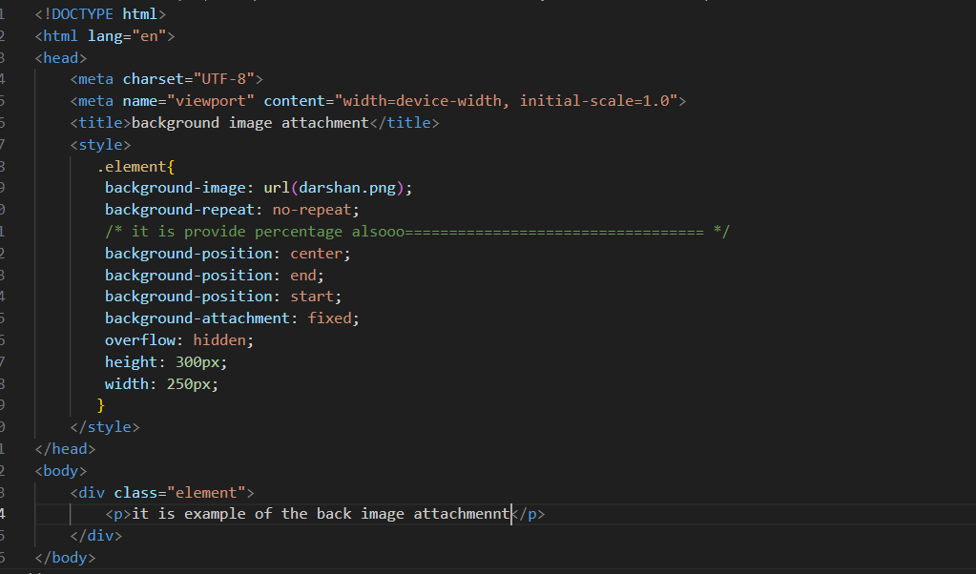

**Q.10) Why should background and color be used as separate properties?**

**Ans)**

=>The background property in CSS is a shorthand property that allows you to set multiple background-related properties in a single declaration.

=>This includes properties like background-color, background-image, background-repeat, background-position, and background-size.

**=>Example:-**

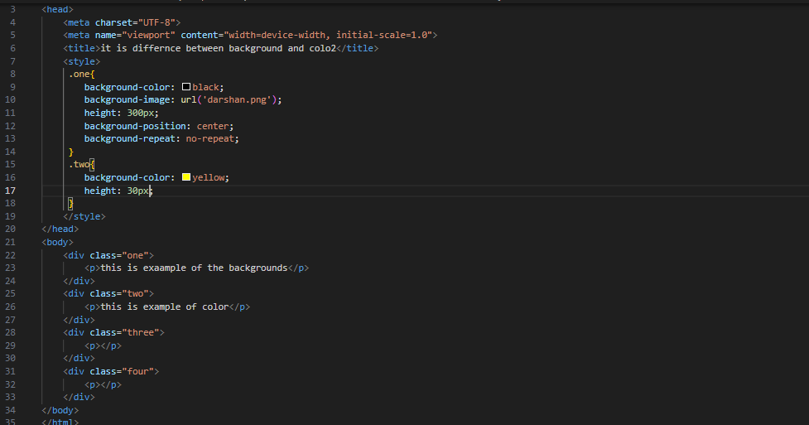

**Q.11) How to center block elements using CSS1?**

**Ans)**

* The center block elements can be achieved using the “text-align” property along with setting the width of the block element.
* **Example:-**

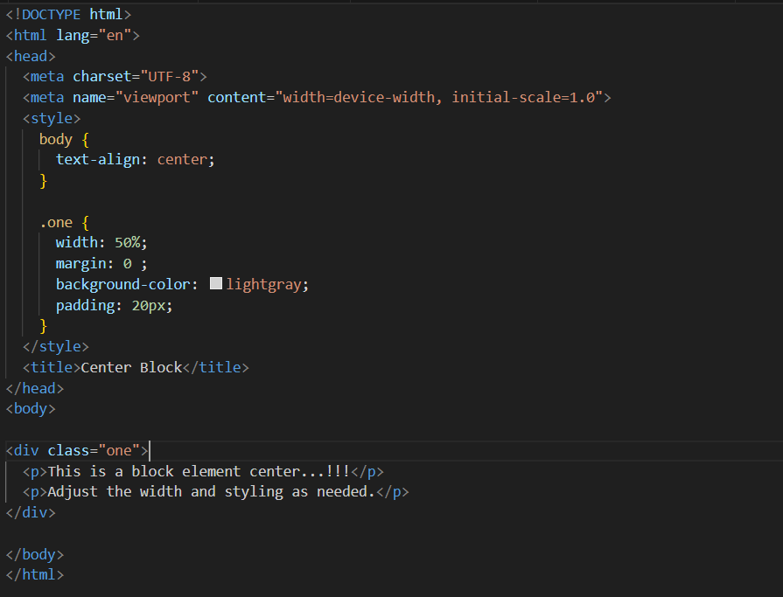

**Q.12) How to maintain the CSS specifications?**

**Ans)**

=>Maintaining CSS specifications involves ensuring that your stylesheets adhere to the latest standards, considering browser compatibility, and organizing your code for readability and maintainability.

**Q.13) What are the ways to integrate CSS as a web page?**

**Ans)**

=>There are three types ways to integrate CSS into a web page.

1. Inline CSS
2. Internal CSS
3. External CSS

**=>Example:-**

**=>Inline CSS:**

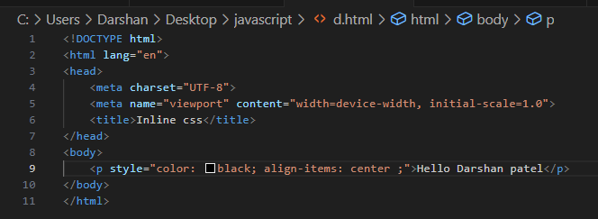

**2.Internal CSS:**

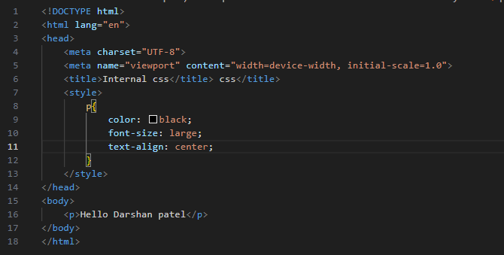

**3.External CSS:**

* HTML:

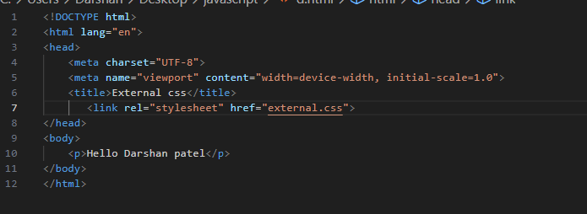

* CSS:

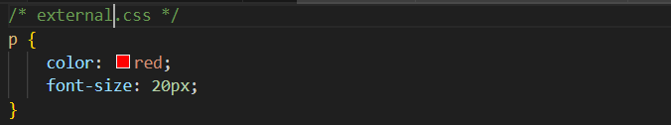

**Q.14) What is embedded style sheets?**

**Ans)**

=>Embedded style sheets, also known as internal style sheets, involve placing the CSS styles directly within the HTML document using the <style> element.

=>This allows you to define styles specific to that document.

**=>Example:-**

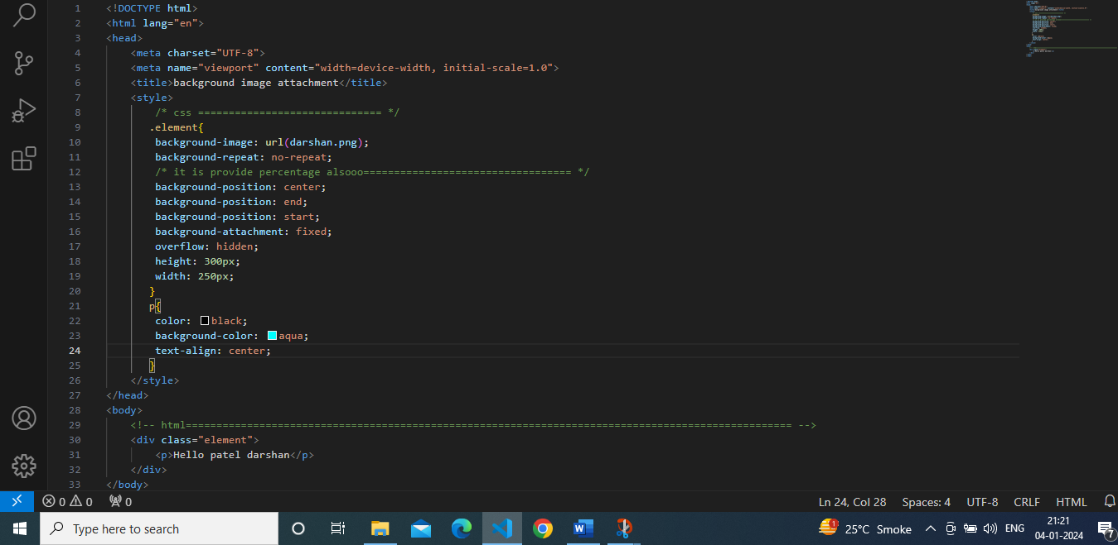

**Q.15) What are the external style sheets?**

**Ans)**

=>External style sheets are files containing style information that can be linked to an HTML document.

=>They allow you to separate the styles of a web page from its HTML.

**=>Example:-**

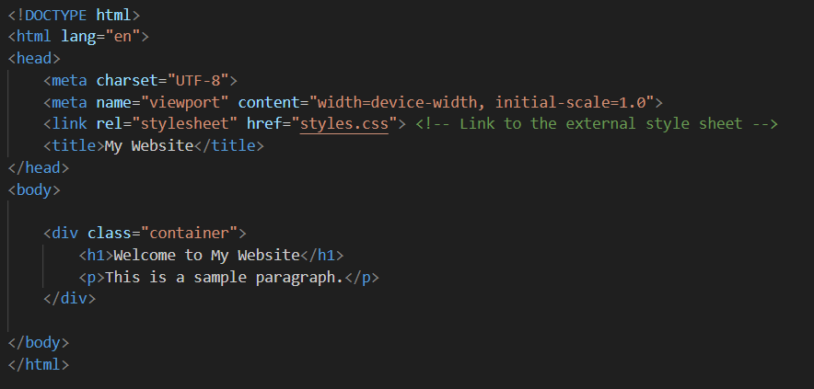

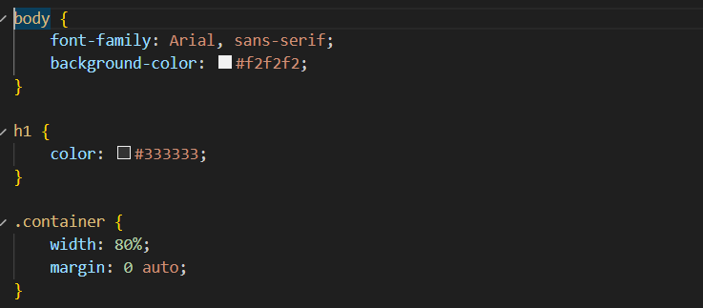

**Q.16) What are the advantages and disadvantages of using external style sheets?**

**Ans)**

**=>Advantages of External Style Sheet :-**

-Consistency Across Multiple Pages

-Easy Maintenance

-Faster Page Loading

-Improve readability and Organization

-Reuse of Style

**=>Disadvantages of External Style Sheet:-**

-Additional HTTP Request

-Possible Delay in Rendering

-Not Suitable for Singal-Use Style

-Dependency on External File

-Learning Curve for Beginners

**Q.17) What is the meaning of the CSS selector?**

**Ans)**

=>The selector is a pattern used to select and style HTML elements on a web page.

=>Selectors target specific elements or groups of elements to which you want to apply styles.

**=>Example:-**

**-Element Selector:-**

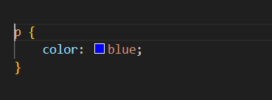

**-Class Selector:-**

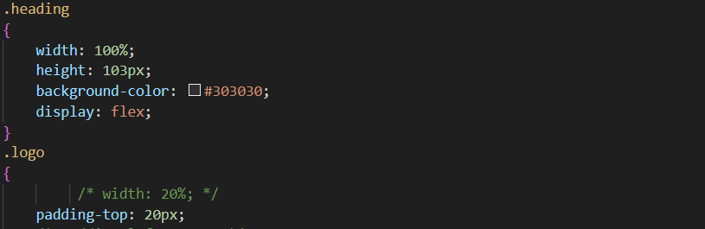

**-ID Selector:-**

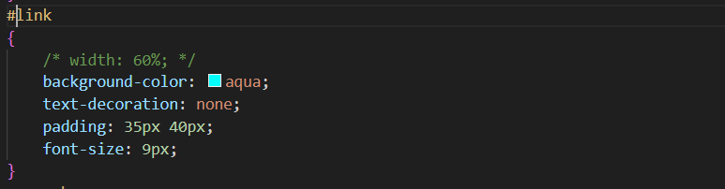

**-Desendant Selector:-**

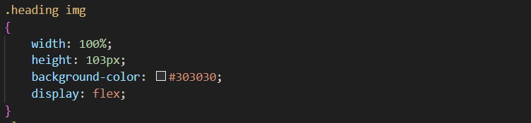

**-Child Selector:-**

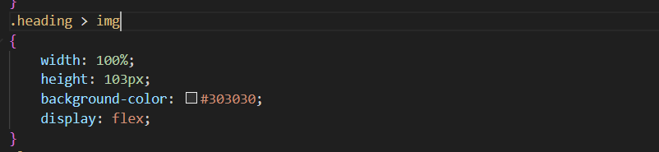

**-Attribute Selector:-**

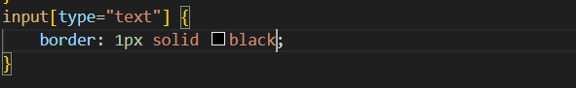

**-Pseudo Class Selector:-**

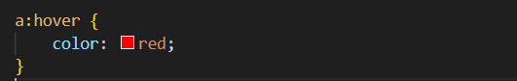

**Q.18) What are the media types allowed by CSS?**

**Ans)**

=>CSS provides several media types that allow you to apply styles based on the characteristics of the output device.

**=>Example:**

* **Screen:(‘screen’)**

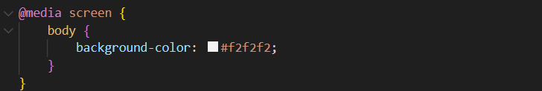

* **Max Width:(‘max-width’)**

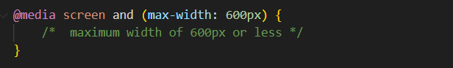

* **Min Width:(‘min-width’)**

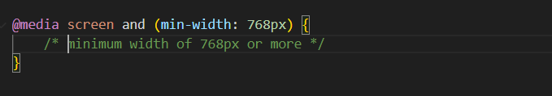

**Q.19) What is the rule set?**

**Ans)**

=>a rule set is a combination of a selector and a declaration block.

**=>Example:-**

